Github tool

Tasks to be performed are to find :

1. What is Github?

2. What all purposes would users of Github use it for?

3. What is a Merge conflict?

4. And to Create a Repository in Github.Add a shellscript that exists on your laptop to the remote Github repository using the command line.

Solutions:

1.Github:

1. Github is a web based code hosting platform for version control and collaboration.
2. It’s used for coding mostly where we can save, share projects and files in the form of Repositories.
3. This platform basically works on Version Control System(VCS)
4. For user to use Github a Github account and Internet access is required.
5. Git is just a version control system that manages and tracks changes to your source code whereas GitHub is a cloud-based hosting platform that manages all your Git repositories.
6. Hub means collaboration where developers can work together on the same lines or files of the code though they are in different places.
7. Git can be used with GUI as well as command-line(GITBASH)

2. Purpose of using Github are:

1. **It makes it easy to contribute to open source projects**
2. Collaboration with people
3. **Documentation is easy**
4. **Showcase your work**
5. **Track changes in your code across version**
6. Backup: In case if a central repository is crashed then anyone can push its local copy to the central server. As while making changes it has to be made on the local repository.

3. Merge conflict:

1. Merge conflicts is a problem that occurs in Github software and faced by users when we merge branches that have competing commits, and software needs your help to decide which changes to incorporate in the final merge.
2. A conflict arises when two separate branches have made edits to the same line in a file, or when a file has been deleted in one branch but edited in the other.
3. Conflicts will most likely happen when working in a team environment.

To resolve it:

1. If your merge conflict is caused by competing line changes, such as when people make different changes to the same line of the same file on different branches in your Git repository, you can resolve it on GitHub using the conflict editor.
2. For all other types of merge conflicts, you must resolve the merge conflict in a local clone of the repository and push the change to your branch on GitHub. You can use the command line or a tool like [GitHub Desktop](https://desktop.github.com/) to push the change.
3. It can handle most merges on its own with automatic merging features.

4. The basic idea is to push the file created (with content in it) to central Repository(Github account) from local repository (My laptop) using Command line and shell scripts.

Steps taken to resolve:

1. To Begin with, **The Gitbash software (Local Repository - act as command line) was installed in my laptop and Github account (Central Repository) was created .**
2. Logging in to Github account a new central repository is created with a appropriate filename. This file is used as main file to push the files from laptop to Github server.
3. The GIT commands used are as follows:
4. Git config –global user.name “Filename.git” (central repository file name)
5. Git config –global user.email “Github account ID”
6. Touch filename.txt
7. Git status
8. Git init
9. Git add filename.txt
10. Git add.
11. Git commit –m “first commit”
12. Git commit –m “after changes”
13. Git remote add origin (URL of cental repository file)
14. Git remote
15. Git push –u origin master
16. All these commands were executed in Gitbash Command line.
17. Once the above commands are used to push the file to the central repository there the file (with data) is stored and allows the other users (Developers) to access/share it worldwide for further developments.

Snapshots of Executed commands with the results are seen below:

1.Filename (.git) of the Central repository created , Github email ID is entered (Using “Config” command) and two files are created using “touch” command (This command is used to create files).

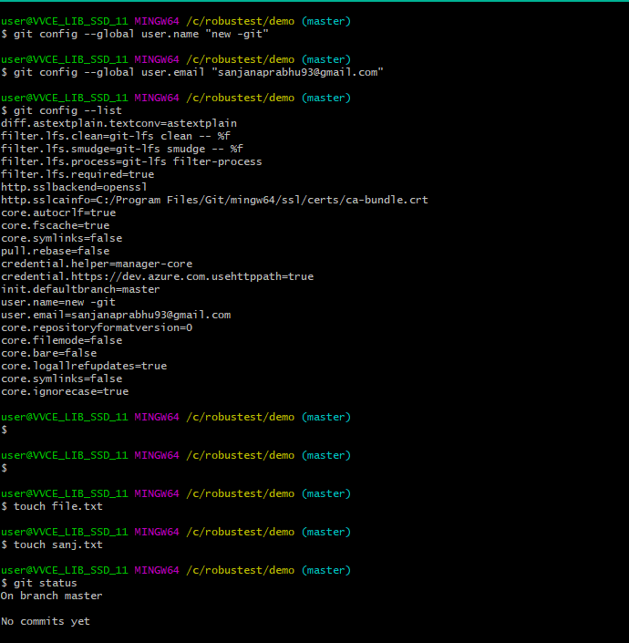

2. Init command to initialize the GIT file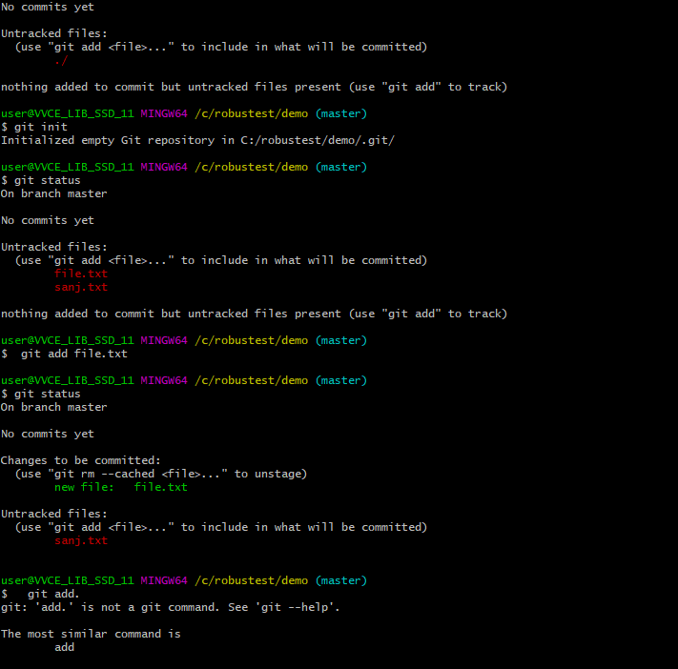

3. Screenshot of .txt Files created (These are located in my laptop that are pushed to Central Repository for futher use)

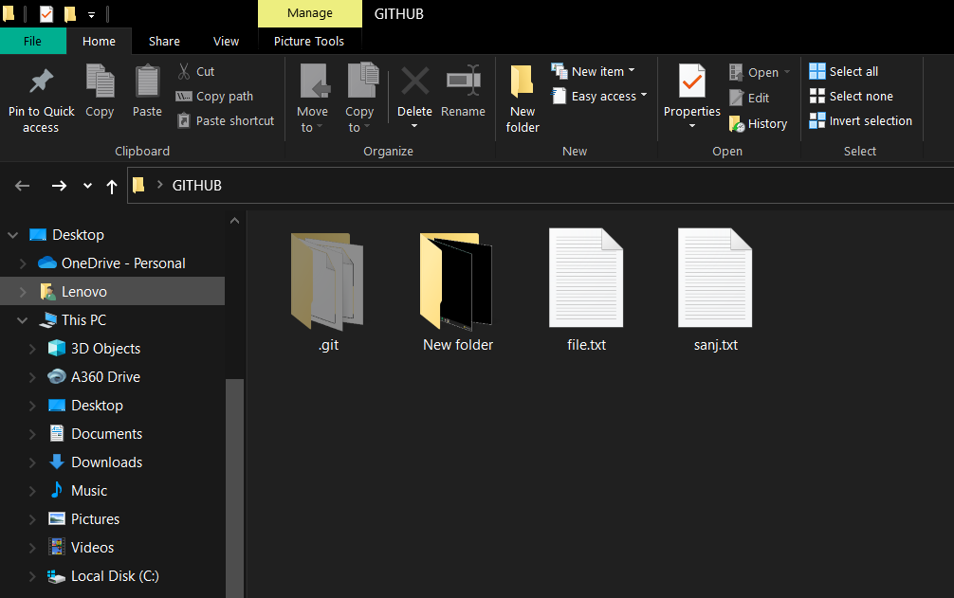

4. Untracked files are converted to Tracked files (“Add” command is used) and changes done in .txt files to add content in it. Data entered in both the files of .txt and verified using commit command.

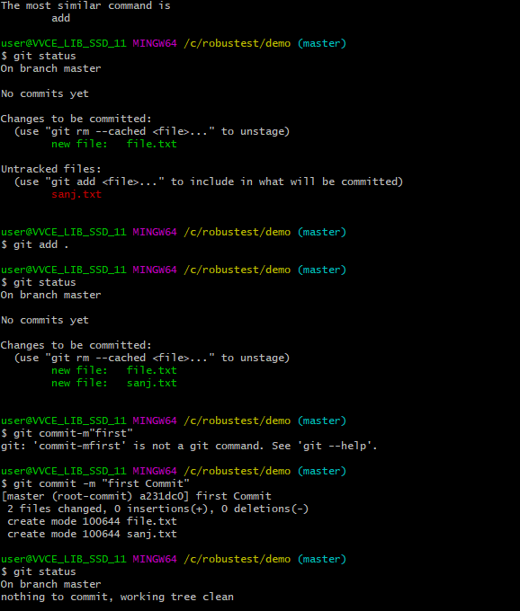.

5.Data entered in both the files of .txt .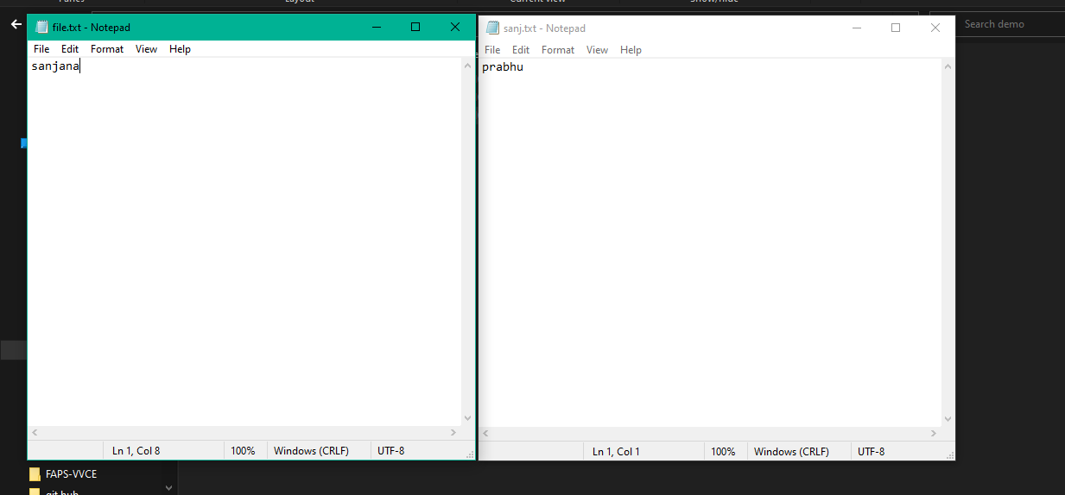

6. Again modified files are converted to tracked files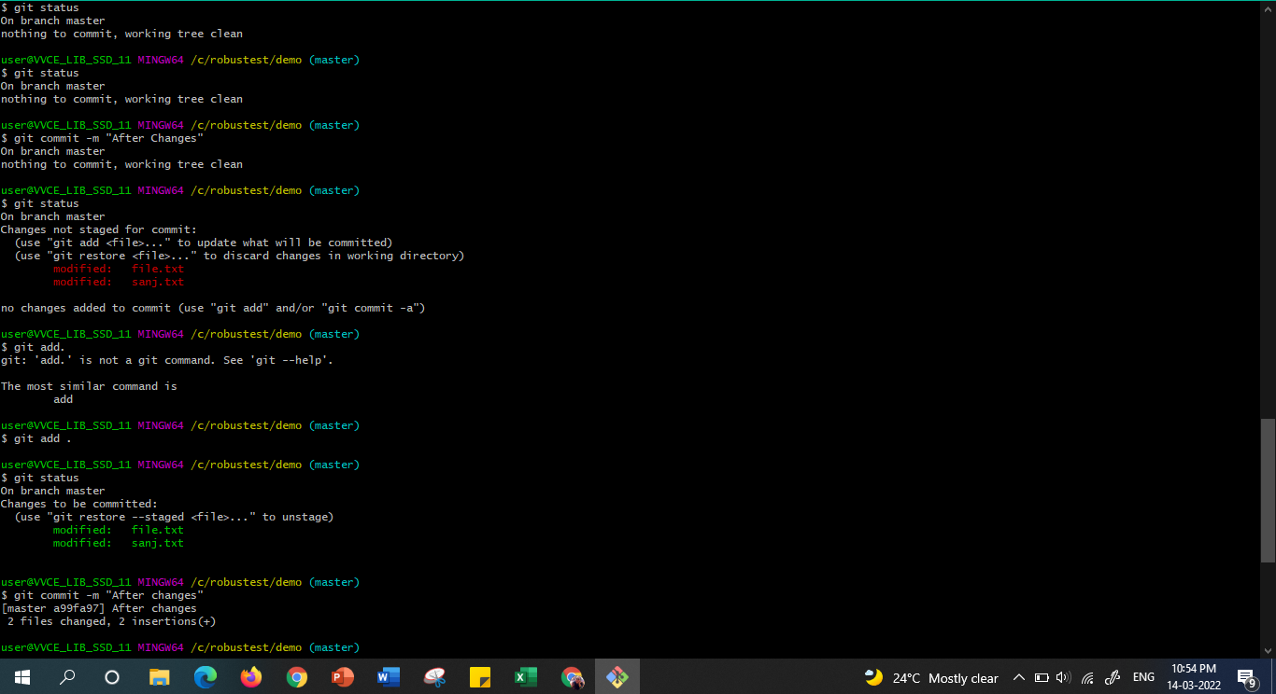7.Remote command is used to push the Remote file to Github(Central Repository)

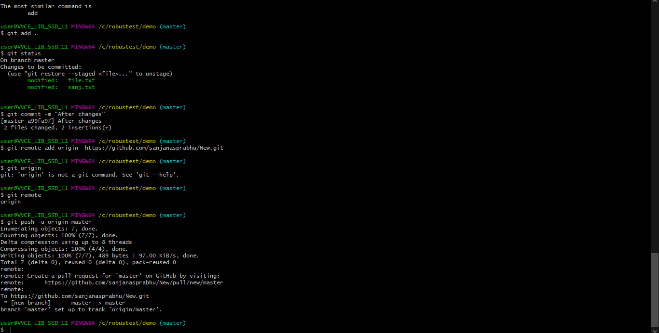

8. The files are pushed with data that was present in the .txt files

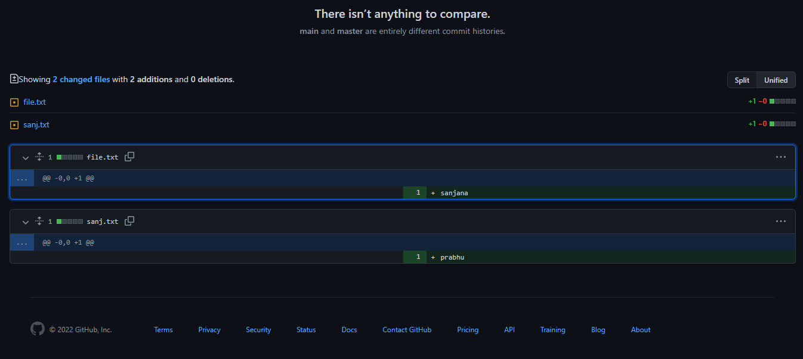

References and Resources:

1. <https://docs.github.com/>
2. <https://www.geeksforgeeks.org/working-on-git-bash/> -Installation steps
3. <https://www.youtube.com/watch?v=xuB1Id2Wxak-steps> to create repository
4. <https://git-scm.com/download/win-> Installation link
5. <https://apiumhub.com/tech-blog-barcelona/using-github/>
6. <https://www.tutorialspoint.com/unix/shell_scripting.htm> - Background study of shell and script was studied.
7. Background study of concepts required to know the working of the tool such as Repository, Types of Repository, Version Control System (VCS), Github and its purpose , Merge conflict, Basics of shell, Difference between Tracked and Untracked files, and few commands of GIT was done to perform above task.